

1. Curriculum Planning and Development Policy (CBCS/OBE)
Purpose
To establish a comprehensive and systematic framework for curriculum planning, delivery, and evaluation in alignment with the Choice Based Credit System (CBCS) and Outcome-Based Education (OBE). The policy aims to promote academic excellence, multidisciplinary learning, inclusivity, and employability among students.
Objectives
- Alignment with Institutional Vision: To ensure curriculum delivery reflects the vision and mission of the institution.
- Regulatory Compliance: To implement CBCS and OBE frameworks prescribed by UGC, APSCHE, and Acharya Nagarjuna University.
- Outcome-Based Learning: To promote student-centric education through clearly defined Course Outcomes (COs), Program Outcomes (POs), and Program Specific Outcomes (PSOs).
- Holistic Development: To integrate value-based education, life skills, and entrepreneurship into the curriculum.
- Inclusivity: To address the academic needs of students from rural and diverse socio-economic backgrounds.
- Employability Enhancement: To strengthen career readiness, higher education preparedness, and entrepreneurial competencies.
Policy Guidelines
Curriculum Framework
- Undergraduate (Single Major Honours) programmes shall follow the curriculum prescribed by APSCHE.
- Postgraduate programmes (MBA & MCA) shall follow the curriculum prescribed by Acharya Nagarjuna University.
- The institution shall strictly adhere to CBCS regulations and academic guidelines issued by affiliating bodies.
Outcome-Based Education (OBE)
- All programmes shall define COs, POs, and PSOs clearly.
- CO–PO mapping shall be carried out using Bloom’s Taxonomy to ensure measurable learning outcomes.
- Outcome attainment shall guide curriculum improvement and teaching strategies.
Academic Preparedness
- Faculty shall prepare Course Files, Lesson Plans, and Academic Plans before the commencement of each semester.
- Syllabus copies (digital and/or printed) shall be provided to students at the beginning of the semester to ensure transparency and preparedness.
Curriculum Enrichment
- Departments shall offer Value-Added Courses (VACs), certificate programmes, and skill-based training (minimum 30 hours).
- Multidisciplinary and elective courses shall be promoted in alignment with NEP 2020.
Inclusive Academic Support
- Bridge courses and remedial classes shall be conducted for first-generation and rural-background learners.
- Special academic mentoring shall be provided to support diverse learning needs.
Implementation Mechanism
Academic Planning: IQAC shall prepare and disseminate the Institutional Academic Calendar aligned with university schedules.
Departmental Execution: Curriculum implementation shall be carried out through department meetings and academic planning sessions.
Teaching-Learning Process:
Adoption of ICT-enabled and blended learning methods (LMS, Google Classroom, etc.)
Continuous internal assessment and structured teaching plans
Student Induction: Orientation and bridge programmes shall be conducted at the beginning of each academic year.
Oversight: The Principal and Academic Council shall monitor effective curriculum delivery and compliance.
Syllabus Completion: Faculty shall ensure timely completion of syllabus as per the academic schedule.
Monitoring, Evaluation, and Feedback
Outcome Assessment
Regular CO–PO attainment analysis shall be conducted using direct and indirect assessment methods.
Academic Monitoring
Verification of lesson plans, course files, and ICT usage by faculty.
Monitoring of syllabus coverage and classroom delivery.
Feedback Mechanism
Structured feedback from students shall be collected at the end of each semester through digital platforms (such as Google Forms) under the supervision of the Principal to ensure transparency and effective evaluation of the teaching–learning process.
Structured feedback shall be collected from :Students, Alumni , Employers , Faculty
Action Taken Reports (ATR) shall be prepared and documented.
Quality Assurance
Academic and Administrative Audit (AAA) shall be conducted periodically.
IQAC shall review policy implementation and recommend improvements.
Continuous Improvement
- Corrective measures shall be implemented based on feedback, audit findings, and outcome analysis to ensure curriculum relevance and quality.
Institutional Distinctiveness
- Rural Student Empowerment: Focus on communication skills, digital literacy, and academic support for rural learners.
- Transparent Academic Practices: Open feedback systems and regular student–principal interactions.
- Skill Integration: Every student shall complete at least one skill-based or industry-relevant programme.
- Smooth Academic Transition: Bridge courses and mentoring support for students transitioning from Intermediate to Degree education.

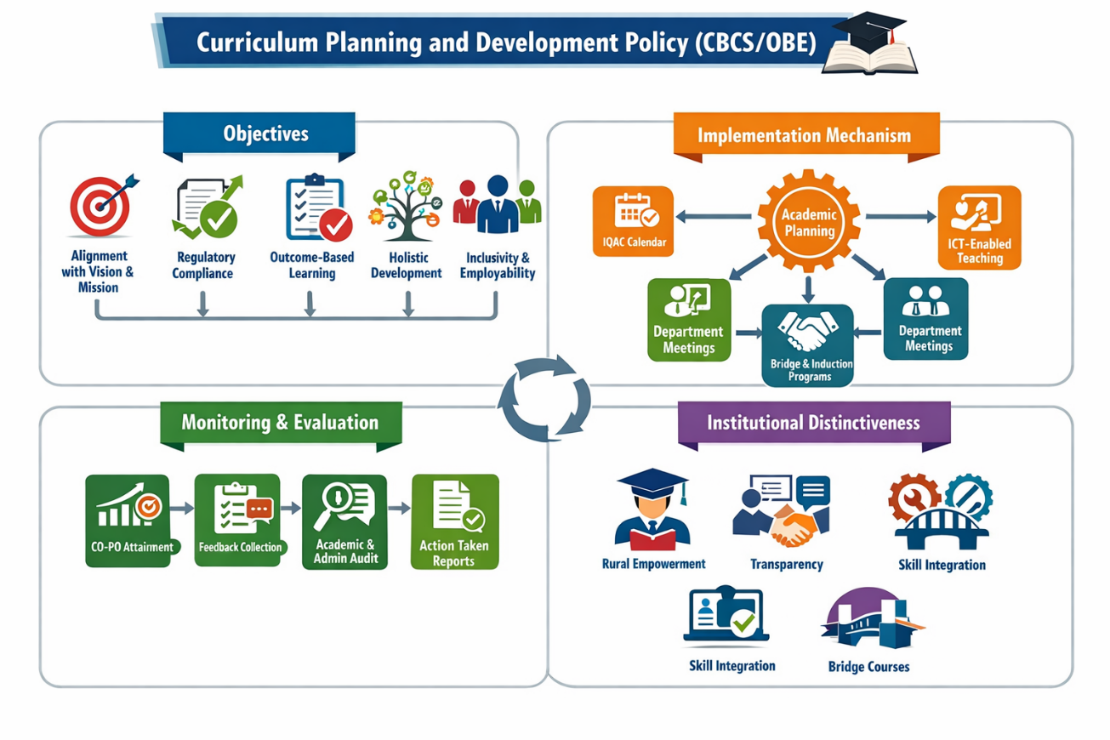
Approval and Review
- Effective Date: June 2024
- Review Cycle: Annual / Semester-based review
- Responsible Authority: Principal & IQAC Coordinator

